|  |  |  |  |  |  |
| --- | --- | --- | --- | --- | --- |
| **Test No.** | **Test Data/Action** | **Reason/Explanation** | **Test type** | **Expected Result** | **Actual Result (screenshot #)** |
| 1 | Does the user see the Upload Button on launch? | User needs to see the Upload button to be able to import images into the program. This is in my Fundamental Objectives 1 | Typical | Button should be visible. | Pass  (1) |
| 2 | Does the zoom Indicator change with the usage of the zoom buttons | The zoom indicator is meant to help the user with seeing how far zoomed they are. | Typical | Zoom indicator should double when the “+” button pressed, and halve when “-” button pressed | Pass  (2) |
| 3 | Does the Price Conversion box accept negative | The price should never be a string | Erroneous | The price conversion should not allow me to put in a string, nothing should show | Pass (no need for screenshot since the input was rejected and nothing changed) |
| 4 | Clicking shape button. | User can create the shape by pressing the button | Typical | A rectangle should appear on screen. | Pass (Rectangle appears) (3) |
| 5 | Clicking and dragging the circle at the side of a rectangle. | This should resize the shape. | Typical | The shape should increase in width when dragging right. | Pass (4) |
| 6 | Clicking a rectangle | This should show custom layer buttons on the side. As the layer is selected. | Typical | Should show the colour buttons, layer up and down buttons + more. | Pass (5) |
| 7 | Clicking off a rectangle | This should deselect the layer | Typical | Should hide the Buttons on the right side and box around the rectangle is hidden. | Pass (6) |
| 8 | Ticking Show Dimensions Box | This should make the rectangle display its length and width. | Typical | Should display the length and width in text on top of the layer. | Pass (7) |
| 9 | Clicking shape button when there is already one rectangle on the canvas | One of my key objectives is to support multiple rectangles | Typical | Should create another rectangle on the screen | Pass (8) |
| 10 | Moving opacity slider to the left | User should have full control over the rectangle | Typical | Should make the rectangle more see through | Pass (9) |
| 11 | Clicking scale button | User should be able to control the scale which pixels translate to, to get to this it has to set the right mode. | Typical | Mode Should = “Scale”  Cursor should be a crosshair. | Pass (10) |
| 12 | Dragging whilst in scale mode | User should be able to control the scale from pixels to real units. | Typical | User should be able to click and drag around screen with a line drawn. | Pass (11) |

**Testing**

|  |  |  |  |  |  |
| --- | --- | --- | --- | --- | --- |
| **Test No.** | **Test Data/Action** | **Reason/Explanation** | **Test type** | **Expected Result** | **Actual Result (screenshot #)** |
| 13 | Releasing from a drag in scale mode | Give user control of scale | Typical | Bring up dialogue to get the unit quantity | Pass (12) |
| 14 | Upload button clicked | Allow user to upload image | Typical | Bring up file dialogue | Pass (13) |
| 15 | Resize window | User experience – useful to allow multi resolution | Typical | The Panels on the side of the screen will move inwards | Pass (14) |
| 16 | Change Colour in colour dialogue | Allow user to have full control over layers | Typical | The colour of the rectangle should change to the colour which was selected. | Pass (15) |
| 17 | Click Save | Allow user to save their work to resume it later | Typical | The user should download a file to their pc. | Pass (16) |
| 18 | Click Load | The user should be able to upload their file which they saved earlier. | Typical | The user should be able to load in a file that they have previously saved (from clicking save button) | Pass (17) |
| 19 | Distance function | Test the distance function | Typical | The distance function should output 1 for the input data of 1,1,2,1 | Pass (18) |
| 20 | Calculate Total Distance function | Test if the total distance is correct | Typical | For a 10 x 10 square, the total area should be 100 | Pass (19) |
| 21 | Change the zoom using changeZoom() | Test if the zoom is changed correctly | Typical | The zoom should be multiplied with each use of the change zoom function | Pass (20) |
| 22 | Image Uploaded | To meet objective 1, I must have images. The image must show correctly on the screen. | Objective | The image of ratatouille should appear on the screen when uploaded | Pass (21)  **Evidence of meeting Objective 1** |
| **Test No.** | **Test Data/Action** | **Reason/Explanation** | **Test type** | **Expected Result** | **Actual Result (screenshot #)** |
| 23 | Image rotation | To meet objective 2, the user must be able to rotate the image they uploaded. | Objective | The image should be rotated different to its normal position in test 21 | Pass (22)  **Evidence of meeting Objective 2** |
| 24 | Image navigation | To meet objective 3, the user must be able to zoom in, zoom out and move the image around. | Objective | The image should zoom in when zoom in button clicked, zoom out when out button clicked and when dragged, move around following mouse. | Pass (23)  **Evidence of meeting Objective 3** |
| 25 | Create Rectangles | To meet objective 4, the user must be able to create rectangles |  | When the shape button is pressed a rectangle should appear on screen | Pass (24)  **Evidence of meeting objective 4** |
| 26 | Show sizes with a real scale | To meet objective 5 the user must be able to have a real scale. |  | After the user has set the scale, If the show dimensions button has been pressed, dimensions of the shape will be shown in real units. | Pass (25)  **Evidence of meeting objective 5** |
| 27 | User interface | To meet objective 6 the program must have a user interface (graphical) |  | After the program is loaded, a graphical user interface should appear. | Pass (26)  **Evidence of meeting objective 6** |
| 28 | Multi Rectangle | To meet objective 7 the program must support multiple rectangles at once. |  | If the shape button is pressed multiple times the program should allow the user to control each rectangle and not crash. | Pass (27)  **Evidence of meeting objective 7** |
| 29 | Convert Virtual Units into Real units. | To meet objective 8 the program must be able to convert real world units, i.e. a length into the real-world equivalent. |  | If the measure tool is used the user should be able to drag to create a length, which will be converted into real units. | Pass (28)  **Evidence of meeting objective 8** |
| 30 | Usability | To meet objective 9 the program must be usable. |  | Since this is subjective, I will interview my end user and get their opinion on this. | Pass  Comments by end user:  “The user interface seems very easy to use, it’s very intuitive. It’s all on the screen so I can see what I need to do there and then. It definitely can quote out jobs how I need it to”  **Evidence of meeting objective 9** |

**Screenshots of Tests**

1. 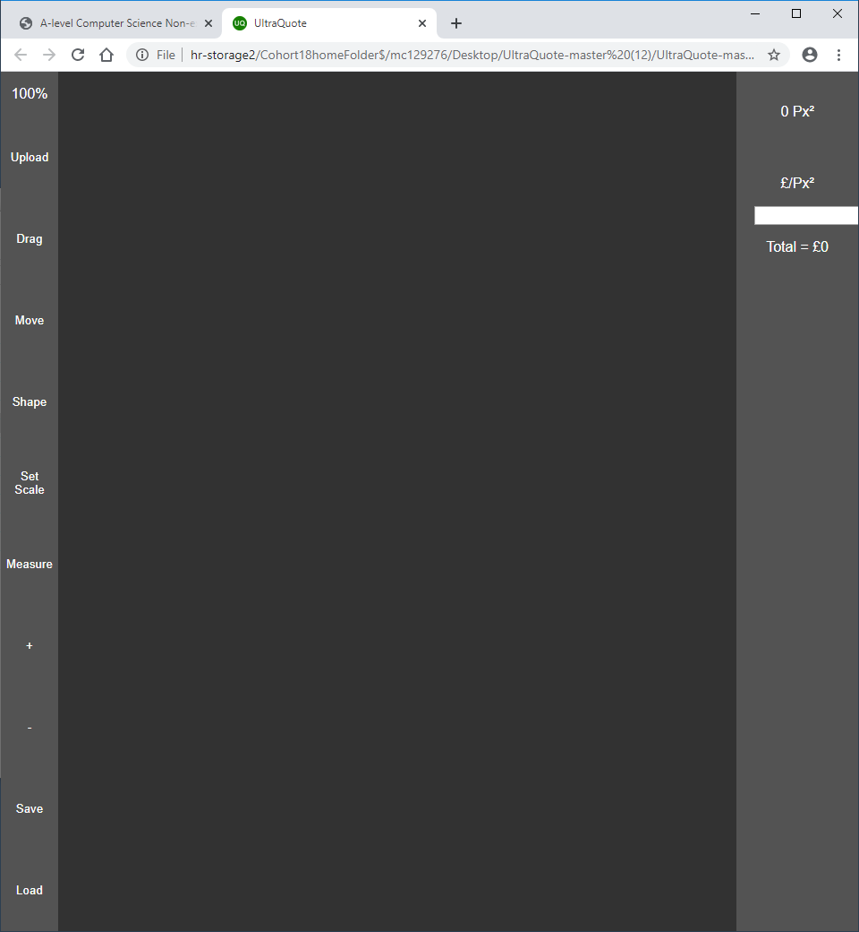
2. 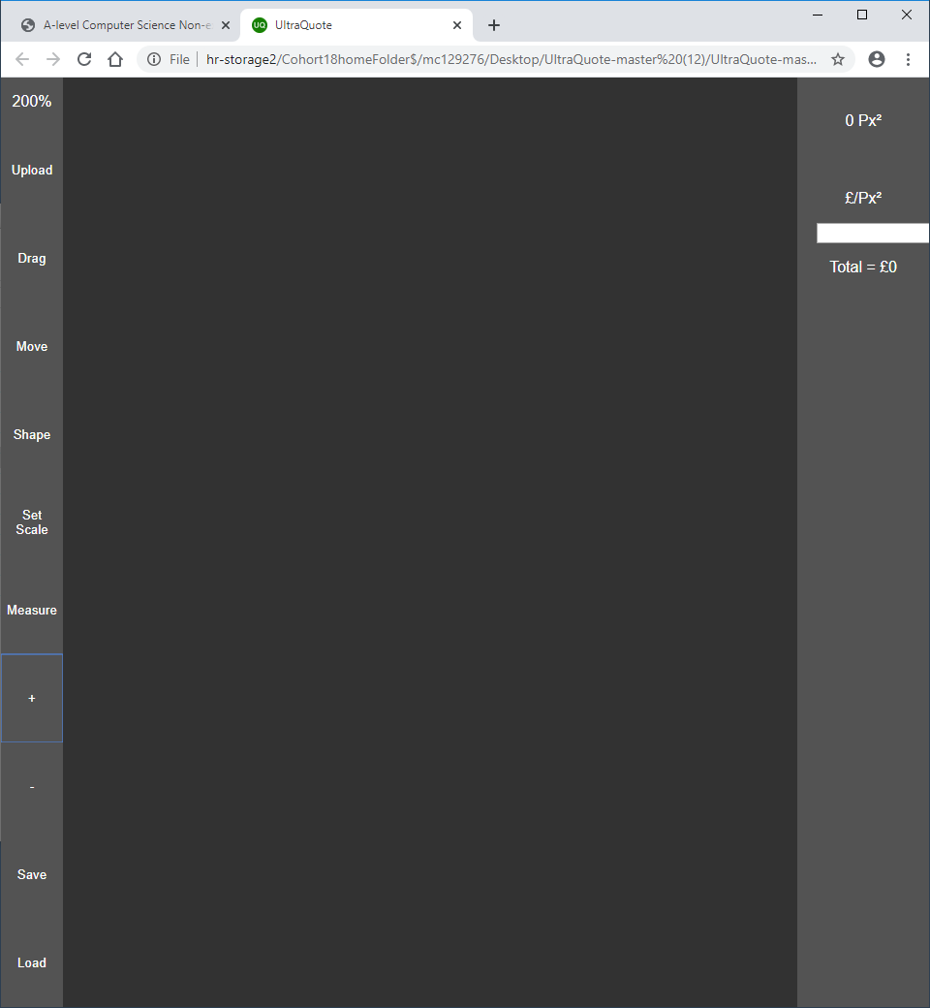
3. 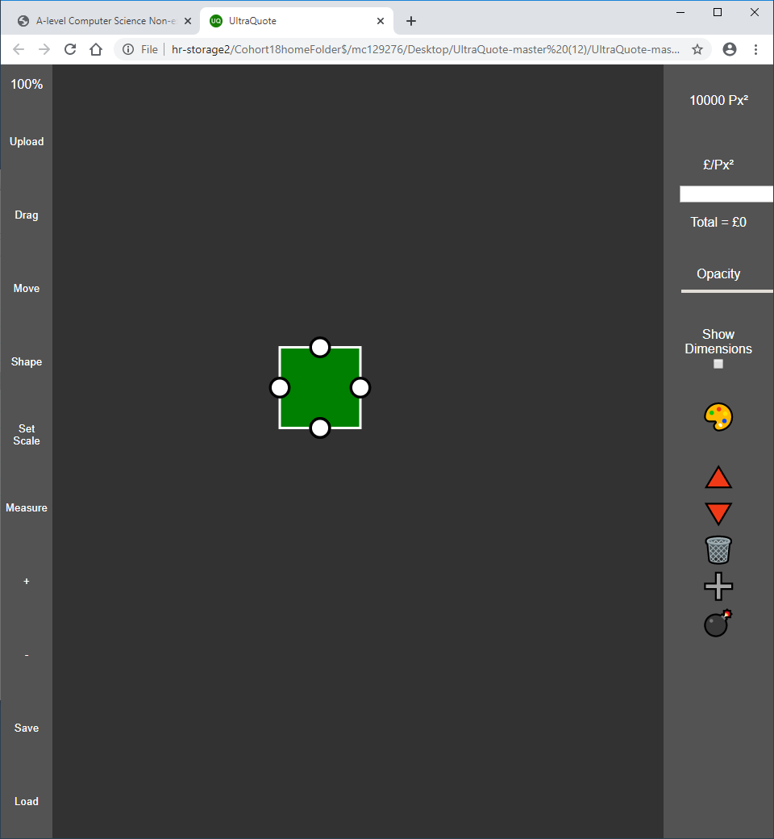
4. 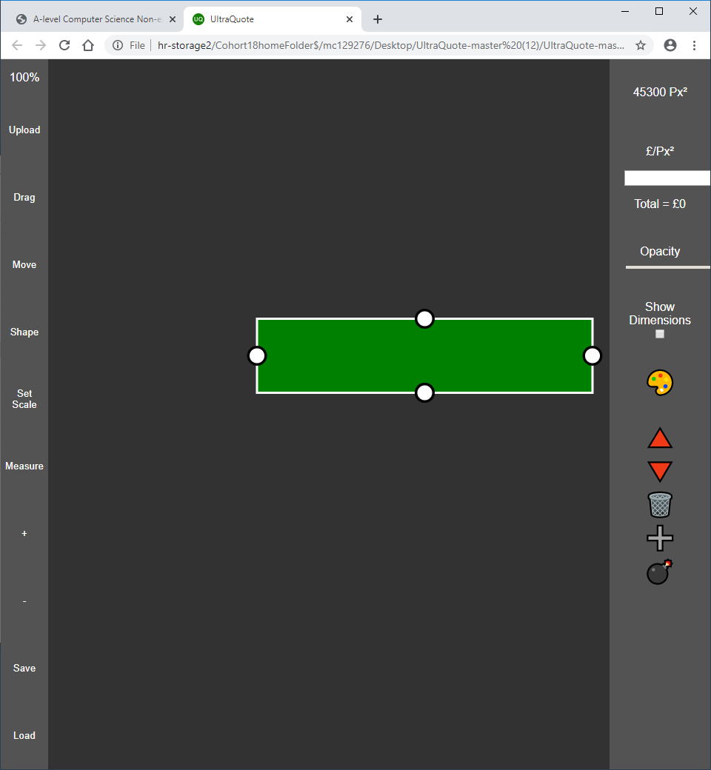
5. 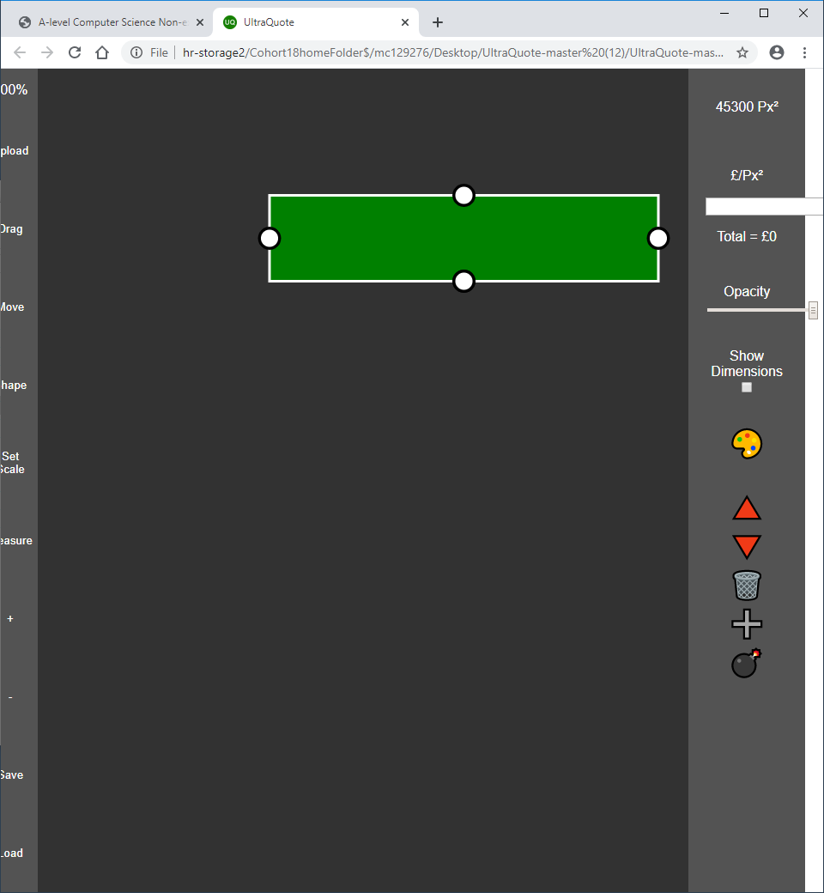
6. 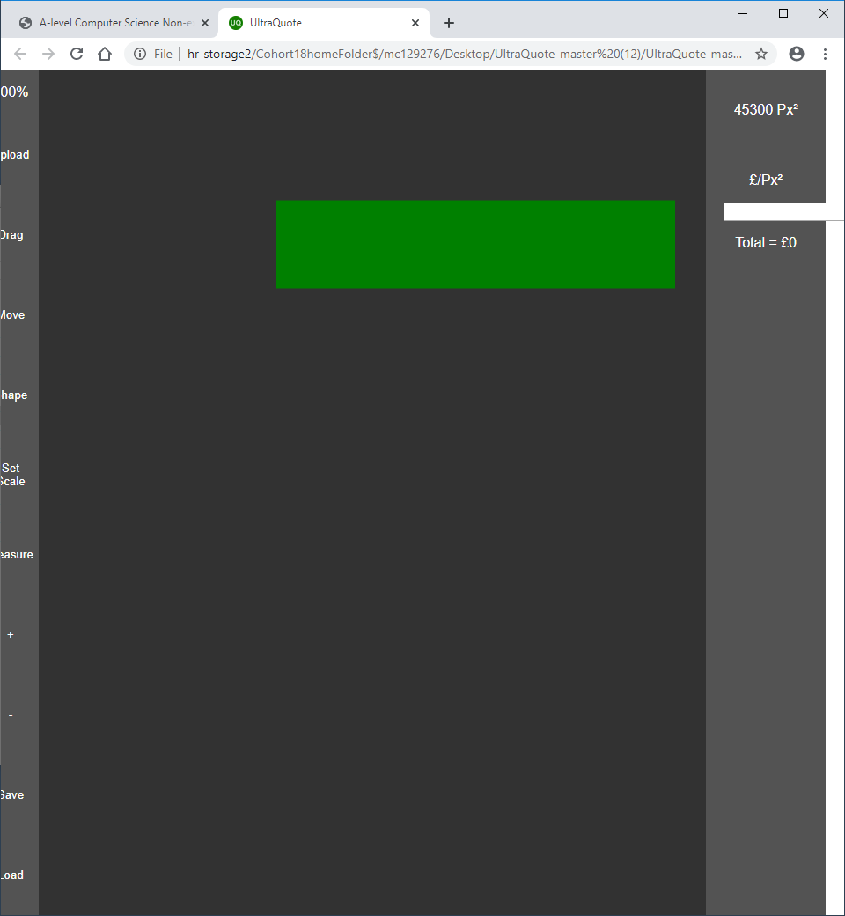
7. 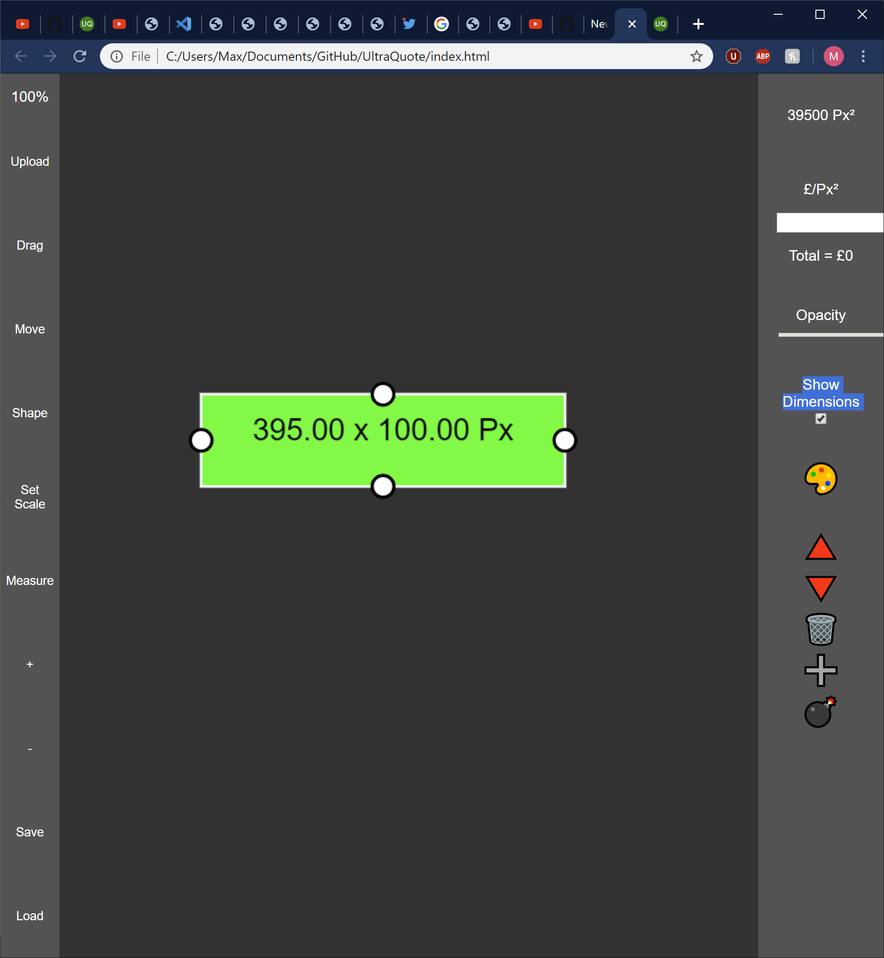
8. 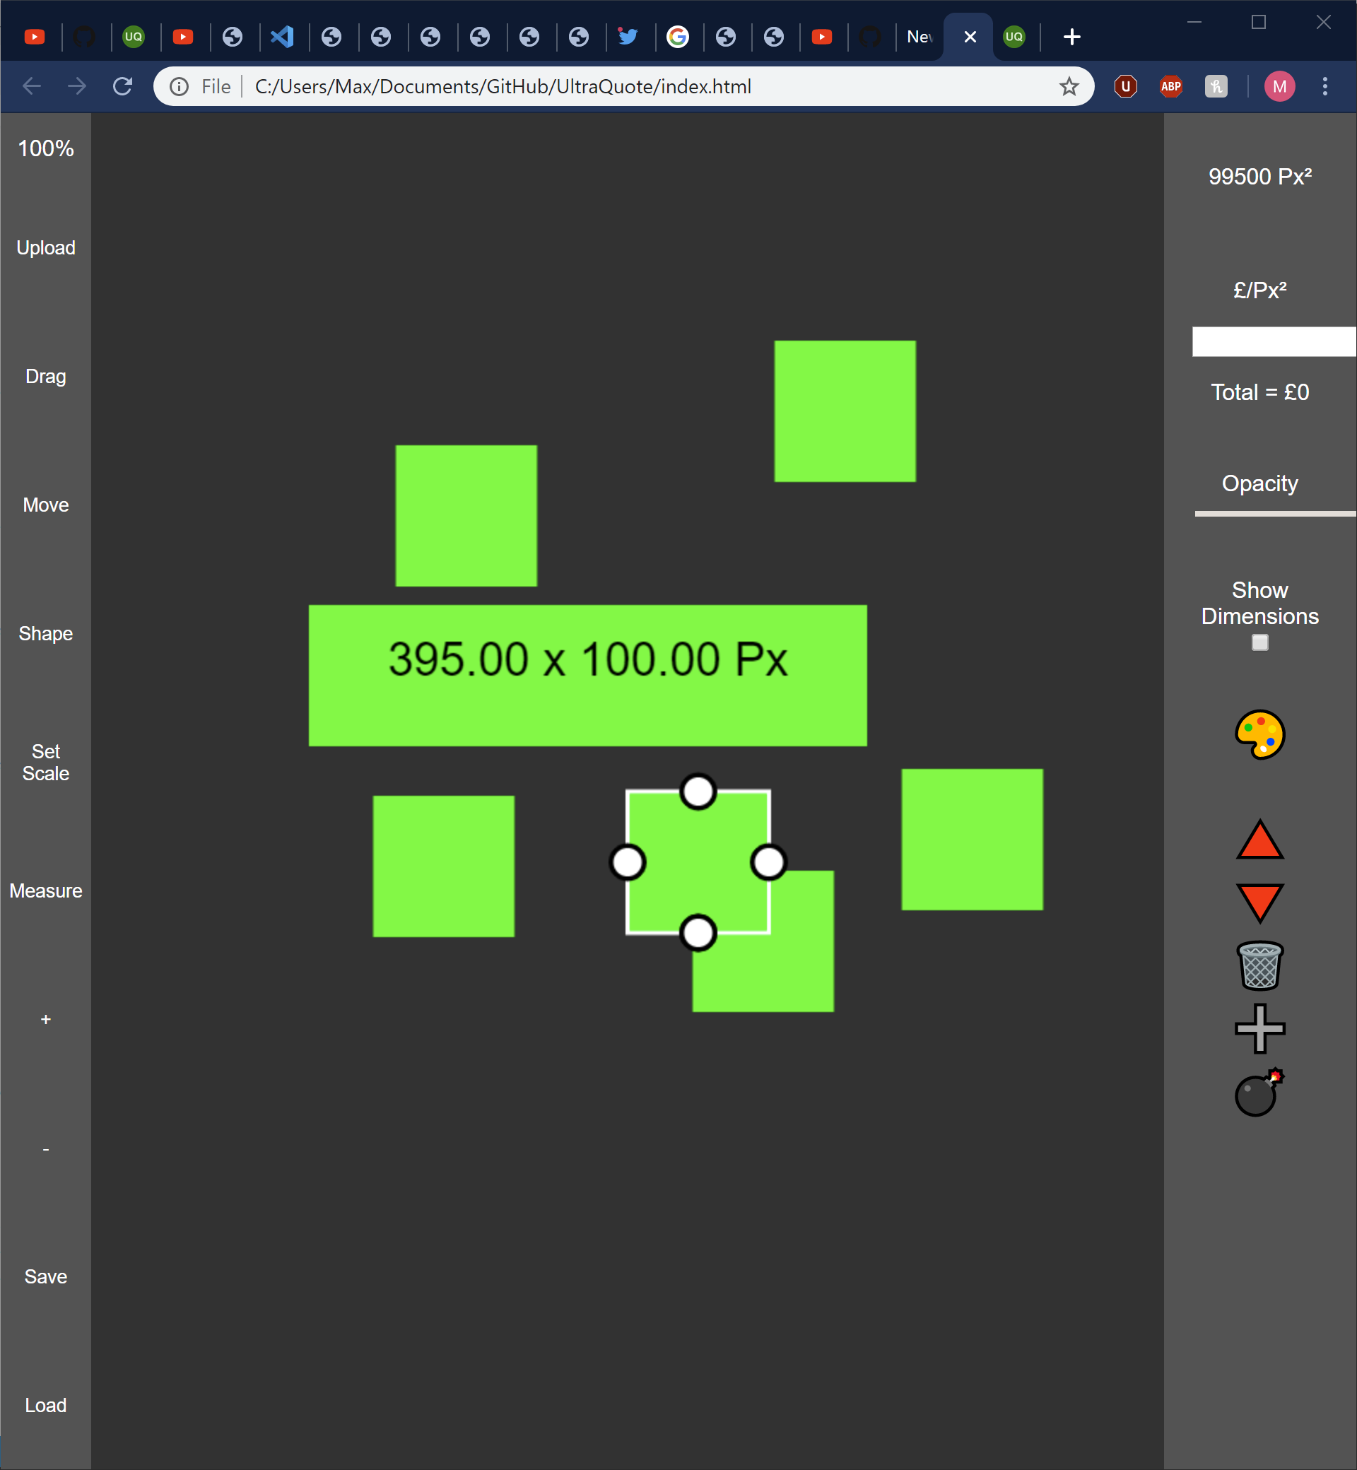
9. 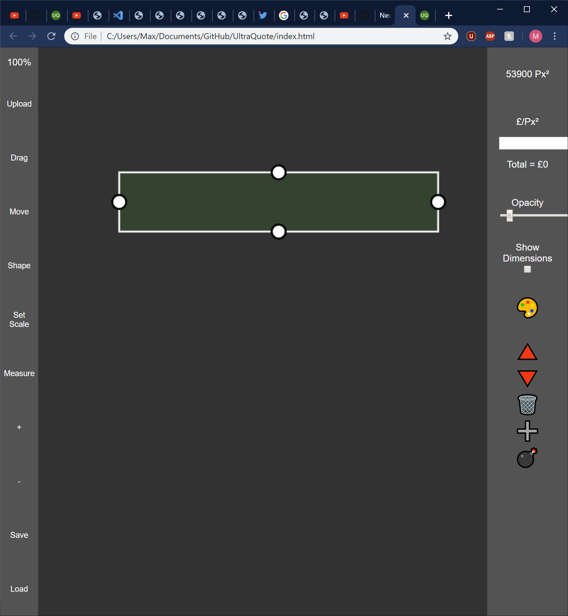
10. 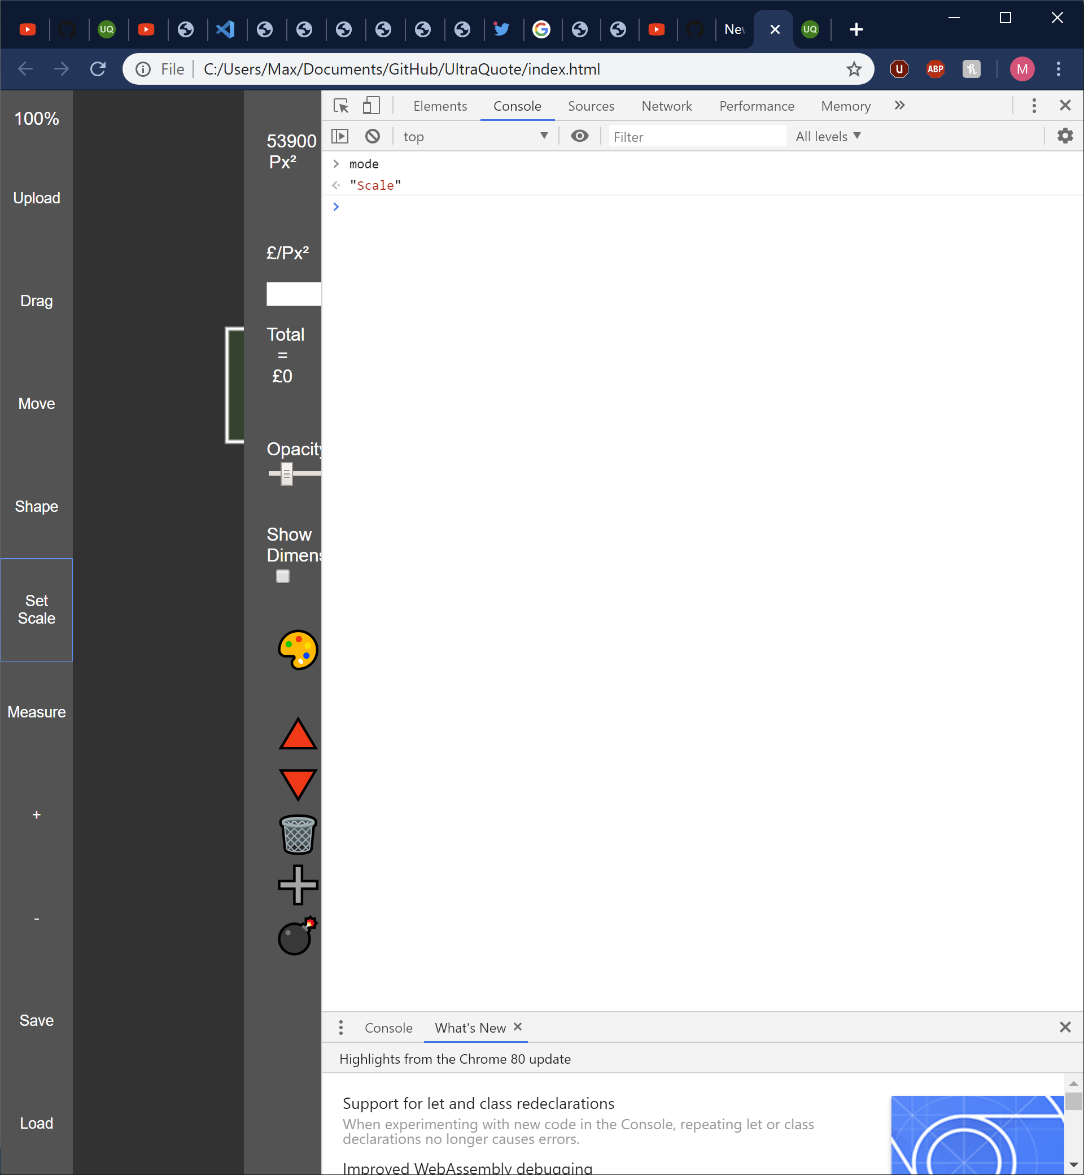
11. 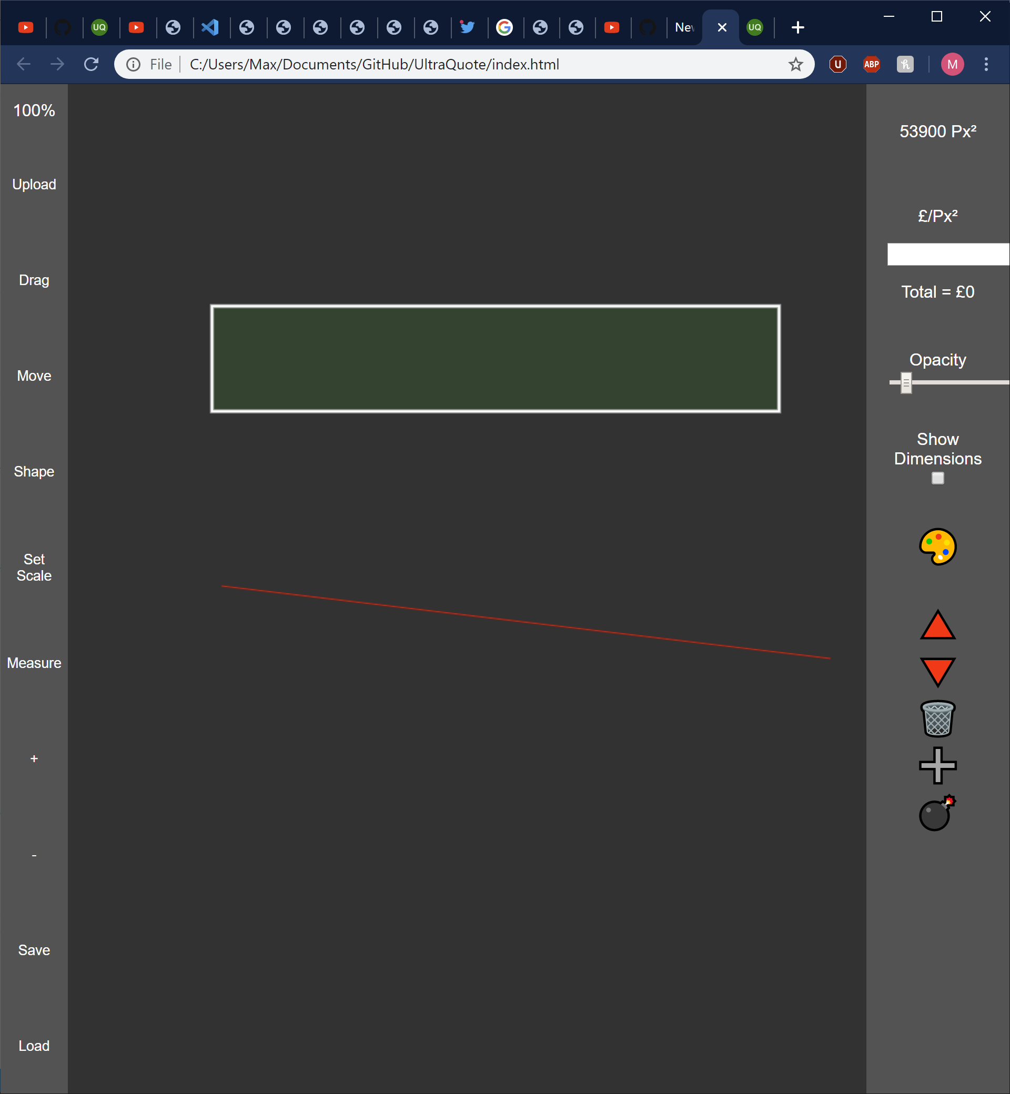
12. 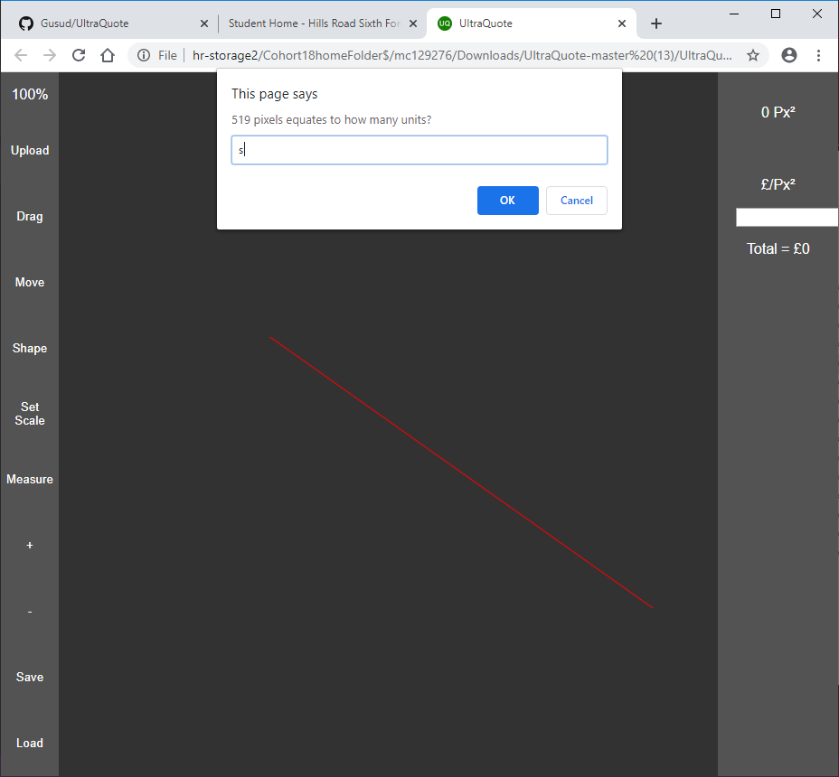
13. 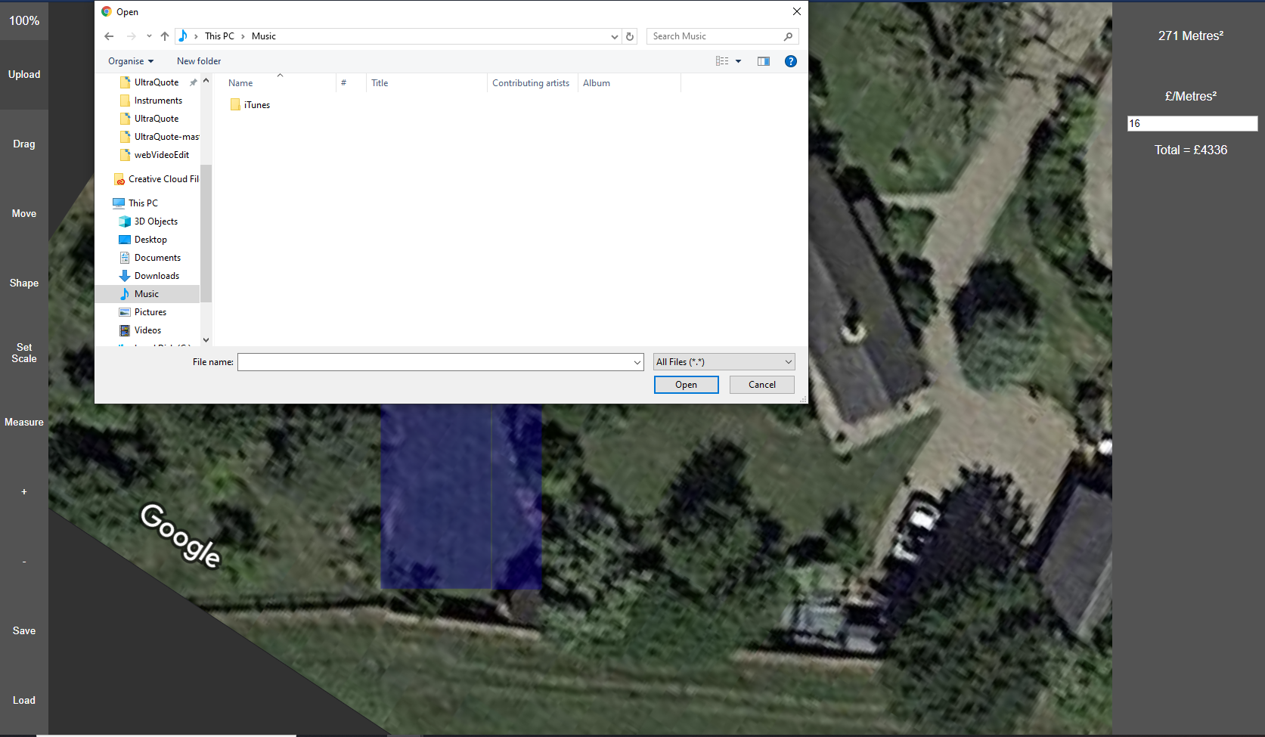
14. https://www.youtube.com/watch?v=pXcBCRXdPnE
15. https://youtu.be/nuk0nOOQYVQ
16. 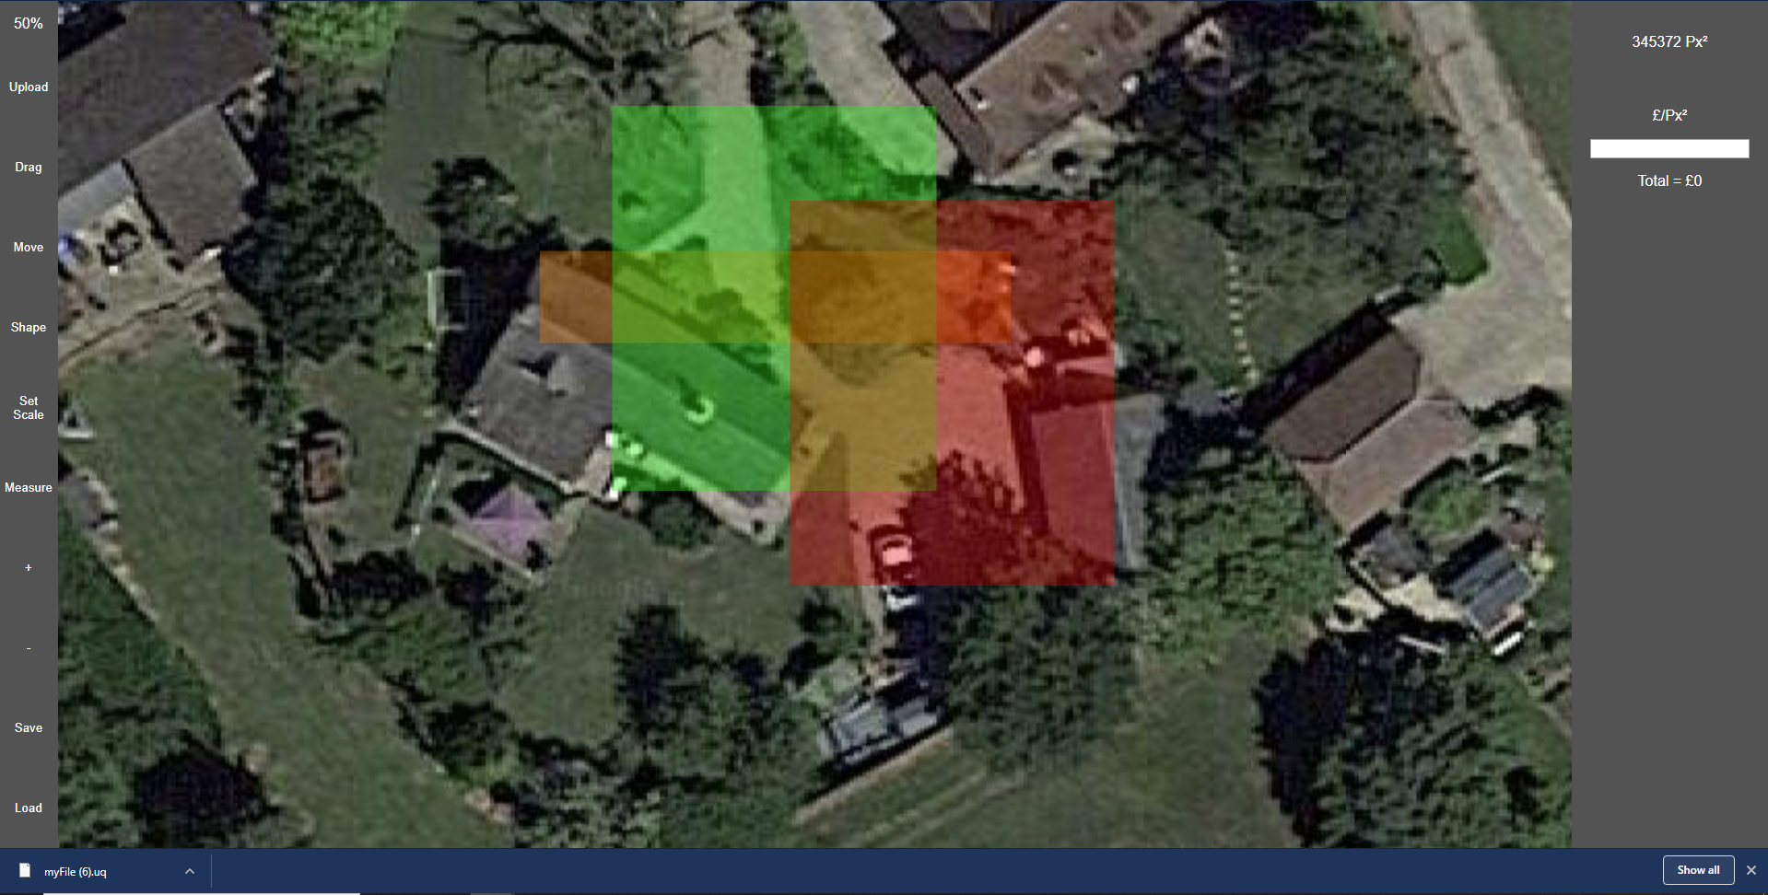
17. https://youtu.be/M2BiKNquQW4
18. 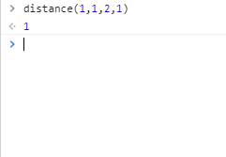
19. 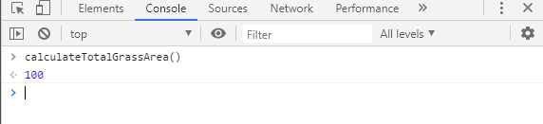
20. 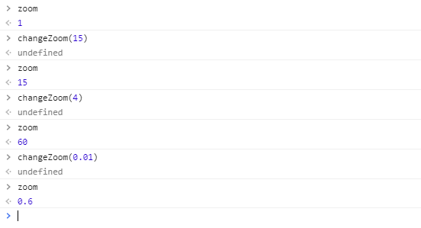
21. 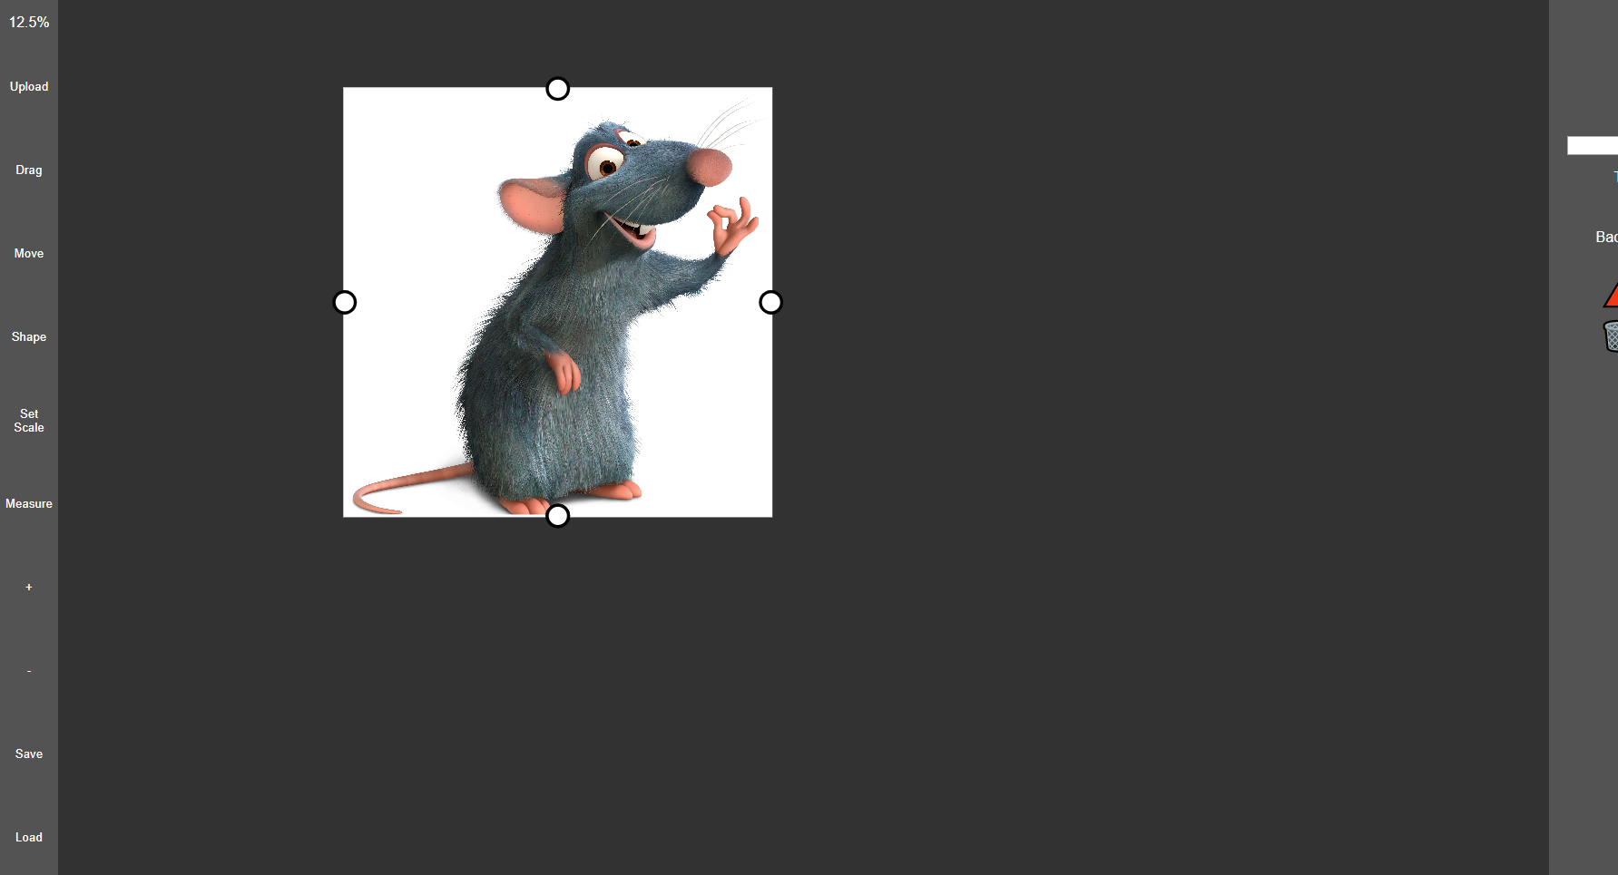
22. 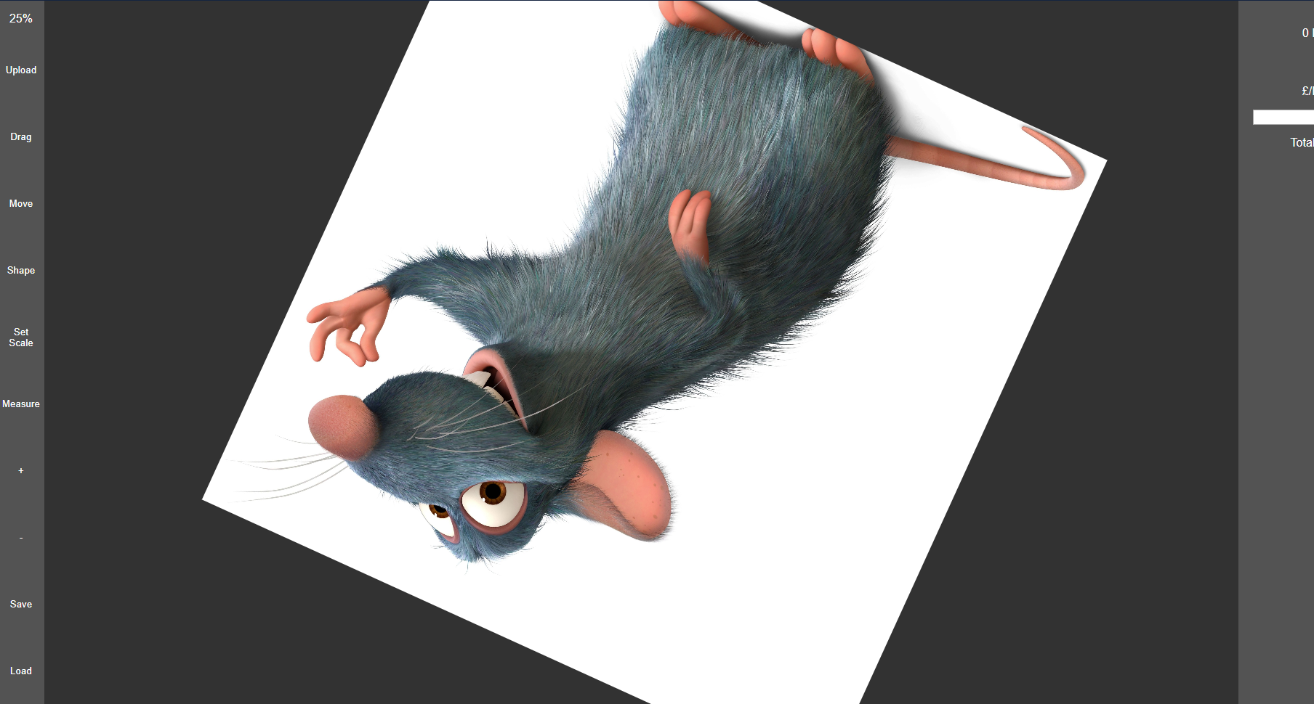
23. https://youtu.be/esGfeetO0Jc
24. https://youtu.be/_Q96AjR-7m0
25. https://youtu.be/oscK-ApMwMg
26. https://youtu.be/s7zYZ3XCSvM
27. 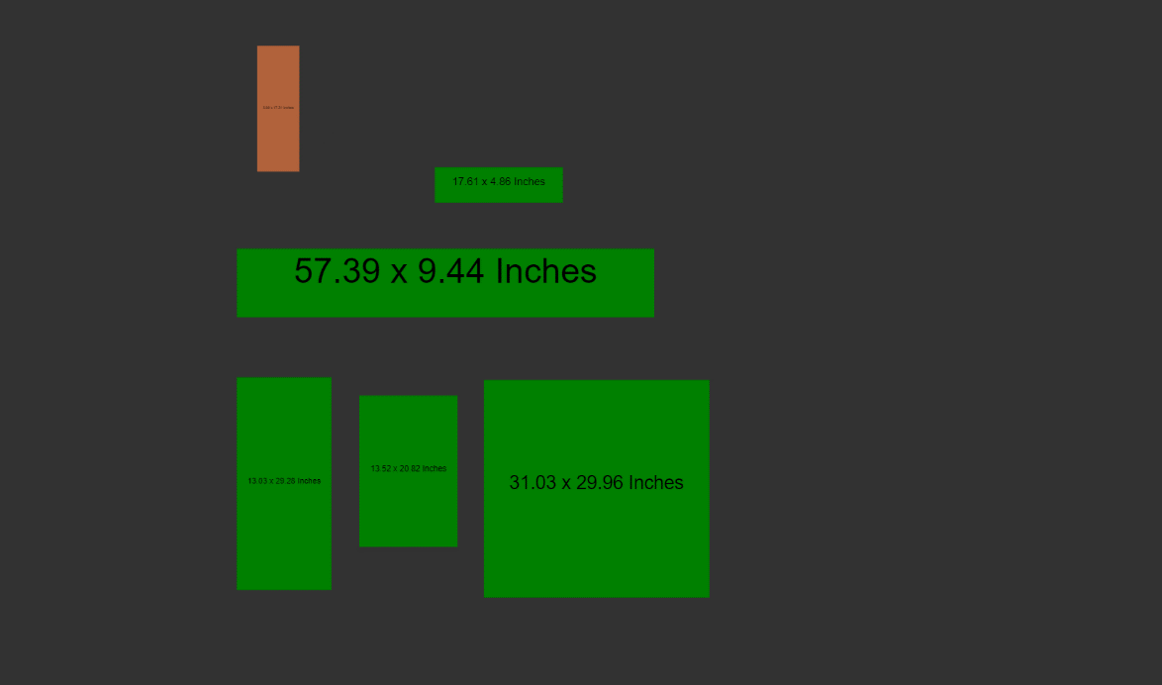
28. https://youtu.be/ff0iAQWPxpk